Materi Java Database Menggunakan MySQL

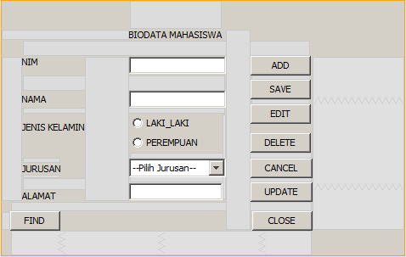

Buatlah database dengan nama database_nim

Buatlah table dengan nama mahasiswa

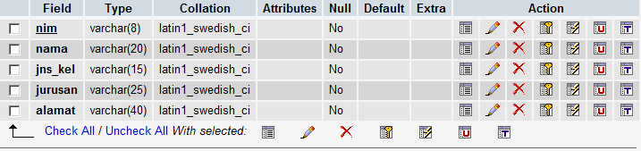

Skrip Program

package koneksi;

import java.sql.*;

import javax.swing.JOptionPane;

import com.mysql.jdbc.Driver;

**public class koneksi** {

Connection conn;

Statement st;

ResultSet rs;

void testkoneksi(){

{

try{

Class.forName("com.mysql.jdbc.Driver");

conn=DriverManager.getConnection("jdbc:mysql://localhost/dedi","root","password");

st=conn.createStatement();

JOptionPane.showMessageDialog(null,"Koneksi berhasil : ");

}

catch(Exception e){

JOptionPane.showMessageDialog(null,"Koneksi Gagal : " +e);

}

}}

public static void main(String[]args){

koneksi test = new koneksi();

test.testkoneksi();

System.exit(0);

}

}

package koneksi;

import java.sql.*;

import javax.swing.JOptionPane;

public class bio extends javax.swing.JFrame {

/**

* Creates new form bio

*/

public bio() {

initComponents();

nonaktif();

}

private void baddActionPerformed(java.awt.event.ActionEvent evt) {

// TODO add your handling code here:

bersih();

aktif();

tnim.requestFocus();

}

private void bsaveActionPerformed(java.awt.event.ActionEvent evt) {

// TODO add your handling code here:

String nim=tnim.getText();

String nama=tnama.getText();

String alamat=talamat.getText();

String jenis="";

if(rlaki.isSelected())

jenis="Laki-laki";

else

jenis="Perempuan";

String jurusan=cjurusan.getSelectedItem().toString();

try{

Statement mysql=koneksi.getConnection().createStatement();

String simpan="insert into mhs values('"+nim+"','"+nama+"','"+jenis+"','"+jurusan+"','"+alamat+"');";

mysql.executeUpdate(simpan);

mysql.close();

JOptionPane.showMessageDialog(null,"Data tersimpan","Information",JOptionPane.INFORMATION_MESSAGE);

bersih();

nonaktif();

}

catch (Exception e){

JOptionPane.showMessageDialog(null,"Data tersimpan","Information",JOptionPane.WARNING_MESSAGE);

}

}

private void bcancelActionPerformed(java.awt.event.ActionEvent evt) {

// TODO add your handling code here:

nonaktif();

bersih();

}

**private void bfindActionPerformed(java.awt.event.ActionEvent evt) {**

// TODO add your handling code here:

String nim=tnim.getText();

String jenis="";

try{

Statement cari=koneksi.getConnection().createStatement();

String tampil="Select * from mhs where NIM like '"+nim+"'";

ResultSet rs=cari.executeQuery(tampil);

if(rs.next()){

tnim.setText(rs.getString(1));

tnama.setText(rs.getString(2));

if(jenis.valueOf(rs.getString(3)).toString().equals("Laki-laki"))

rlaki.setSelected(true);

else

rperempuan.setSelected(true);

cjurusan.setSelectedItem(rs.getString(4));

talamat.setText(rs.getString(5));

}

else{

JOptionPane.showMessageDialog(null,"Data Tidak Ada","Information",JOptionPane.INFORMATION_MESSAGE);

bersih();

}

}

catch (Exception e){

JOptionPane.showMessageDialog(null,"Gagal"+e,"Warning",JOptionPane.WARNING_MESSAGE);

}

}

**private void bcloseActionPerformed(java.awt.event.ActionEvent evt) {**

// TODO add your handling code here:

System.exit(0);

}

**private void bdeleteActionPerformed(java.awt.event.ActionEvent evt) {**

// TODO add your handling code here:

String nim=tnim.getText();

String jenis="";

try{

Statement cari=koneksi.getConnection().createStatement();

String hapus="delete from mhs where NIM like '"+nim+"'";

cari.executeUpdate(hapus);

cari.close();

JOptionPane.showMessageDialog(null,"Data Terhapus","Information",JOptionPane.INFORMATION_MESSAGE);

bersih();

}

catch (Exception e){

JOptionPane.showMessageDialog(null,"Data gagal dihapus"+e,"warning",JOptionPane.WARNING_MESSAGE);

}

}

**private void beditActionPerformed(java.awt.event.ActionEvent evt) {**

// TODO add your handling code here:

aktif();

tnim.setEditable(false);

**}**

**private void bupdateActionPerformed(java.awt.event.ActionEvent evt) {**

// TODO add your handling code here:

String nim=tnim.getText();

String nama=tnama.getText();

String alamat=talamat.getText();

String jenis="";

if(rlaki.isSelected())

jenis="Laki-laki";

else

jenis="Perempuan";

String jurusan=cjurusan.getSelectedItem().toString();

try{

Statement ken=koneksi.getConnection().createStatement();

String update="update mhs set NAMA='"+nama+"',jns_kel='"+jenis+"',jurusan='"+jurusan+"',alamat='"+alamat+"' where nim like '"+nim+"'";

ken.executeUpdate(update);

ken.close();

JOptionPane.showMessageDialog(null,"Data Terupdate","Information",JOptionPane.INFORMATION_MESSAGE);

bersih();

}

catch(Exception e){

JOptionPane.showMessageDialog(null,"Gagal update"+e,"warning",JOptionPane.WARNING_MESSAGE);

}

**}**

**void bersih(){**

tnim.setText("");

tnama.setText("");

buttonGroup1.clearSelection();

cjurusan.setSelectedIndex(0);

talamat.setText("");

**}**

**void aktif(){**

tnim.setEditable(true);

tnama.setEditable(true);

rlaki.setEnabled(true);

rperempuan.setEnabled(true);

cjurusan.setEnabled(true);

talamat.setEditable(true);

//badd.setEnabled(true);

bsave.setEnabled(true);

bcancel.setEnabled(true);

//bclose.setEnabled(true);

//bedit.setEnabled(false);

//bdelete.setEnabled(false);

**}**

**void nonaktif(){**

tnim.setEditable(false);

tnama.setEditable(false);

rlaki.setEnabled(false);

rperempuan.setEnabled(false);

cjurusan.setEnabled(false);

talamat.setEditable(false);

badd.setEnabled(true);

bsave.setEnabled(false);

bcancel.setEnabled(false);

bclose.setEnabled(true);

bedit.setEnabled(false);

bdelete.setEnabled(false);

**}**